Day in the Life of the Hudson River 10/13/22
Nyack Memorial Park, Nyack, NY
RIVER MILE: 28
Salt Front: ~RM75
Nyack High School- Kirsten Kleinman
60 students & 15 adults
Latitude 41.08742 N & Longitude – 73.91576 W
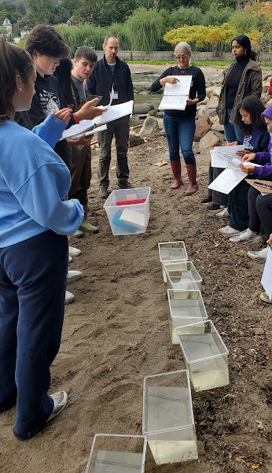 | 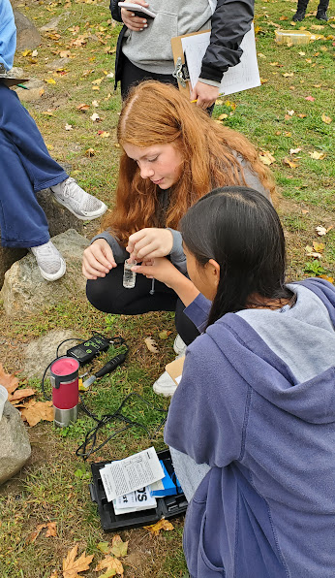 | 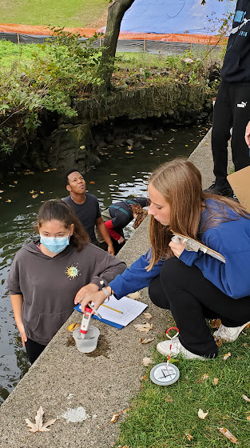 | 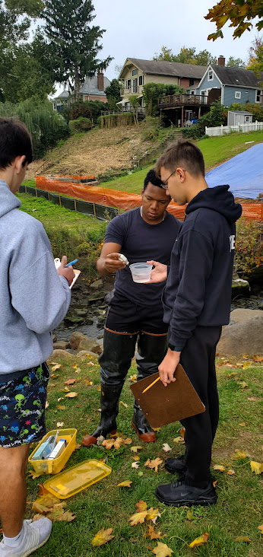

Location: Nyack Memorial Park, Nyack
Area: Drainage pipe from Nyack Brook forming stream that leads into Hudson River
Surrounding Land Use: Forested, beach, park
Sampling Site: Pier, forested, beach, altered banks, grassy, covered in vegetation, RipRap, pipe entering the water
Shoreline: 30% Sandy; 70% Rocky
Water: Choppy
River Bottom: muddy, sandy, rocky
*NR = Not read/recorded
ITEM |  | Time |  | Reading |  |  |  | Comments
Physical
Air Temperature |  | 7:00 AM  11:00 AM |  | 15° C  20°C |  |  | 59°F  68°F
Wind Speed: NR |  | *Noted only that it was windy |  | Anemometer |  |  | Beaufort | Direction
Weather today |  | 9:00 -11:30 AM |  | > 75% cloud cover |  |  | Small Showers @ 10 AM
Weather the past 3 days: |  | Normal, sunny weather past 3 days
Tides- |  | Time |  | Rising, Falling, Unchanged |  |  | Water Height (cm)
 |  | 9:00 AM- 11:30 AM |  | Rising |  |  | 6 cm  38 cm | Low tide at 7 am  High tide at 1 pm
Current- NR |  | Time |  | Cm/sec |  | Knots | North/South | Ebb/Flood/Still
 |  |  |  | *Noted pier and cove with stream flowing into it – not a good place to measure currents
Water Temperature- |  | 11:30 AM |  | 17.8°C
Turbidity- Secchi Disk (cm) |  | 11:30 AM |  | 103.5 cm
Chemical
Salinity- |  | 11:30 AM |  | 10.6 ppt
Standardized Salinity – HR Quantabs |  | 11:50 AM |  | 8,536 ppm
DO – Chemets Kit |  | Time  11:30 AM |  | Temp  17.8°C |  |  | ppm DO  8 ppm | % saturation  NR
pH – Meter |  | 11:30 AM |  | 6.7
Nitrates- |  | 11:30 AM |  | 0 ppm
Phosphates- |  | 11:30 AM |  | 0.4 ppm
Alkalinity- NR
Biological
Fish – Seine |  | Number |  | Name |  |  | Length of longest | Length of smallest
10:00-11:00 AM |  | 1  2  1  50  1  3 |  | Herring sp.  Channel Catfish  Banded Killifish  Atlantic Silverside  White Perch  Striped Bass |  |  | 5 cm  35 cm  5 cm  10 cm  20 cm  12.7 cm | 25 cm  5 cm  5 cm
Fish Totals |  | TOTAL:78 |  | Diversity: 6 |  |  |  | 1 Snapping Turtle 30.4 cm
Macroinvertebrates |  | Number |  | Name |  |  | Length of longest | Length of smallest
 |  | 2  20 |  | Blue Crab  Ctenophore spp. |  |  | 5 cm  5 cm | 2 cm
Macroinvertebrate Totals |  | TOTAL: 22 |  | Diversity:2
Sediment Core -
Length | H2S smell |  | Oxid Top |  | Oil |  | Grain Size | Other Features
Boats-NR
 | Time |  | Name |  | Color |  | North/Southbound | Light/Loaded
NYACK HS TRANSECT MEASUREMENTS – Brook to Hudson
9:00 AM LT
Station # | Distance (M) | Depth (cm) | Salinity ppt | Temp °C | DO ppm | pH
1 | 0 | 6 | 0.6 | 18 | 10 | 7.6
2 | 10 | 10 | 0.6 | 17.6 | 10 | 8.1
3 | 20 | 21 | 0.6 | 17.6 | 10 | 7.4
4 | 30 | 54 | 4.8 | 17.3 | 8 | 7.2
5 | 40 | 115 | 5.6 | 17.8 | 8 | 6.8
6 | 50 |  | 4.9 | 17.4 | 7 | 7.3
7 | 60 |  | 2.3 | 17.4 | 6 | 6.9
8 | 70 | 63 | 7.3 | 17.2 | 8 | 7.0
9 | 80 | 43 | 2.9 | 17.3 | 7 | 7.4
10 | 90 | 28 | 4.6 | 17.7 | 8 | 6.4

 | Nitrates | Phosphates |  | Turbidity cm visibility | Location
Station 1 | 2 ppm | 0 ppm |  | 93 cm | Butterfly garden
Station 10 | 2 ppm | 0.2 ppm |  | 83 cm | Shakey Dock
 |  |  |  | 103 cm | Far Pier
Salinity – not sure where? | Quantab reading | 2.8 |  | 392 ppm Cl- | 708 TS

11:30 AM Rising Tide (HT 1PM)
Station # | Distance (M) | Depth (cm) | Salinity ppt |  | Temp °C | DO ppm | pH
1 | 0 | 38 cm | 2.6 |  | 18.3 | 9.0 | 7.3
2 | 10 | 52 cm | 2.7 |  | 18.0 | 8.0 | 7.5
3 | 20 | 87 cm | 4.4 |  | 17.6 | 8.0 | 7.4
4 | 30 | 100 cm | 6.8 |  | 17.6 | 8.0 | 7.4
5 | 40 | NR | 7.5 |  | 17.9 | 8.0 | 7.2
6 | 50 | NR | 6.7 |  | 17.6 | NR | 7.2
7 | 60 | NR | 8.0 |  | 17.4 | NR | 7.5
8 | 70 | 86 cm | 11.1 |  | 17.6 | NR | 6.5
9 | 80 | 52 cm | 10.6 |  | 18.3 | NR | 6.5
10 | 90 | 75 cm | 10.6 |  | 17.8 | NR | 6.7
 | Nitrates | Phosphates |  | Turbidity cm visibility |  | Location
Station 1 | 2 ppm | 0.2 ppm |  | 103.5 cm |  | Butterfly garden
Station 10 | 0 ppm | 0.4 ppm |  | 94 cm |  | Shakey Dock
 |  |  |  | 93 cm |  | Far Pier

